DSGN 345

Final Report Outline
Danish Galebotswe
Spring 2026

Introduction
The object of this project was to design and manufacture a simple CNC part. The project required a part designed using NX and a manufacturing setup created using NX manufacturing.
The designed part involves a computer mouse-like object on a base with holes at each corner of the base. The design also includes a pocket on the mouse which was mainly for aesthetics and manufacturing requirements of the project.
The part did not have intended functionality except for aesthetics and NX modeling practice.
There were the following manufacturing constraints for the project:
- 6061-T6 aluminum stock • Maximum stock size (4" × 4" × 4")
- Required machining operations:
o Cavity Mill Roughing o Cavity Mill Finishing o Planar Mill Operations o Complex Surface Milling Operation

Part Design

Design Requirements
The design of the part to be simple but manufacturable using the CNC Milling Machine. Therefore, the manufacturability of the part was critical to its design. From the Ford Design Building CNC room, there were only a select few tools that could be used:
- End Mills: 1/16” to ¾”
- Balls Mills: 1/16" to ¾”
- Center Drills
- Standard Drills

CAD Model Development
The part was designed in NX using the following operations:
- Extrude:
  - Create the mouse body o Create the mouse roller o Make the holes at each corner o Make the middle pocket o Make the inner pocket
- Edge blend o Add round edges to the mouse o Add round edges to the roller
  - Add fillets to the base of the mouse for easy ball mill operation
- Revolve
  - Make the small side spheres on the side of the mouse

The part had the following key dimensions and features:
- Mouse back radius: 1.5”
- Mouse front radius: 1”
- Corners holes diameter: 0.25”
Below are the images of the final CAD model.
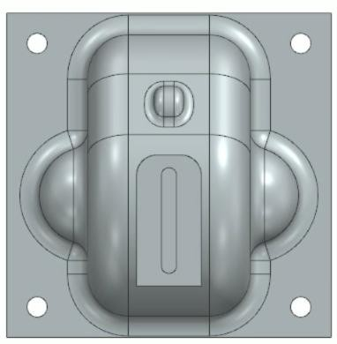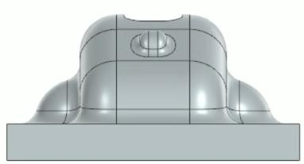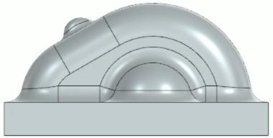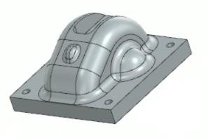

Figure 1: (top-bottom) Top view of the part, front view of the part, size view of the part, and isometric view.
The table below shows how some of the part features fulfill the required manufacturing operations.
Feature | Required Operation
Material Removal | Cavity Mill Roughing
Middle Pocket | Cavity Mill Finish
Pocket Finish Walls | Cavity Mill Finishing
Inner Pocket | Planar Milling
Surface Finish | Complex Surface Milling (Area Mill)
Holes | Hole Making (Non-requirement)

Manufacturing Planning in NX CAM

Manufacturing Setup
The part was assembly with a blank size of 4” x 4” x 2.6065”. The Machining Coordinate System was placed on the top surface of the blank on the left inner corner (corner face the door of the CNC machine. A clearance plane was defined to be 0.5” above the top surface of the blank.
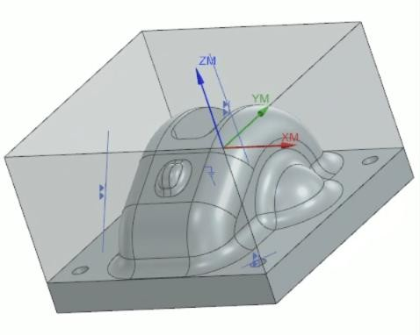
Figure 2: Manufacturing Assembly, MCS Location & Workpiece setup
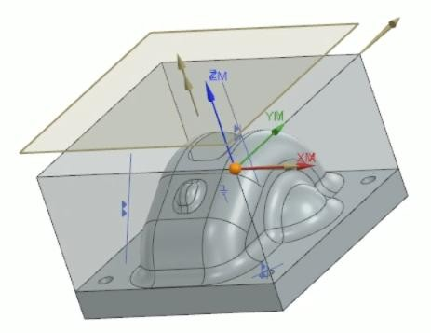
Figure 3: Clearance Plane.

Tool Selection
For each tool:
Tool | Diameter | Type | Purpose
End Mill | ¾ in | Flat End Mill | Roughing
End Mill | ¼ in | Flat End Mill | Finishing
End Mill | 1/8 in | Flat End Mill | Pocketing
Ball End Mill | ¼ in | Ball Nose | Surface Milling
Center Drill | 0.1 in | Center Drill | Center Drilling
Standard Drill | ¼ in | Standard Drill | Hole Making

The ¾” flat end mill was used to initially remove as much material from the blank as possible. A large diameter tool allowed using a large step over and step down which resulted in a much shorter time to remove material. The ¼” flat end mill was used to remove some more material that the ¾” could not remove due to its large size. The ¼” ball end mill was then used to achieve a scallop height of 0.002” on the curved features of the part.

Cutting Parameters
All end mills used had two (2) flutes. Except for the 1/8” flat end mill, center drill and standard drill, a 33.3% step over and step down was assigned to all the tools. This was to avoid tool breakage and rapid tool wear. The table below summarizes the feed rate and spindle speed of the tools.
Tool | Linear Feed rate (ipm) | Spindle Speed (rpm)
¾” flat end mill | 18 | 2,037
¼” flat and ball end mill | 12 | 6,112
Center Drill | 2 | 900
Standard Drill | 12 | 900

Toolpath Development

Cavity Mill Roughing
This operation was conducted using the ¾” flat end mill. It used the follow part cut pattern. The was no in-process workpiece utilization as this process was aimed at removing material in all areas that the tool could access.
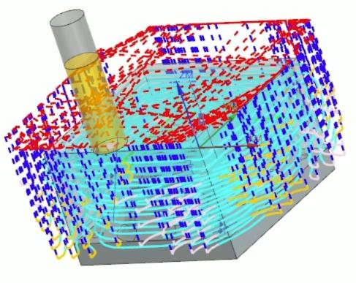
Figure 4: Cavity Mill Roughing with the ¾” flat end mill.
Another cavity mill roughing operation was followed with a ¼” flat and ball end mill with the same cut pattern.
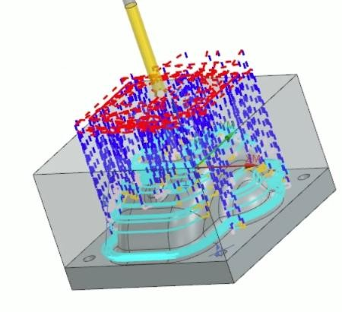
Figure 5: Cavity Mill Roughing with ¼” flat end mill.

Cavity Mill Finishing
This process was conducted with the ¾” end mill and the ¼” flat end mill. The larger tool was used first to remove a lot of the material and then switched to a smaller tool to access areas that that the larger tool could not. A follow part cut pattern used with a 3D in-process workpiece used to avoid machining areas that have already been machined.
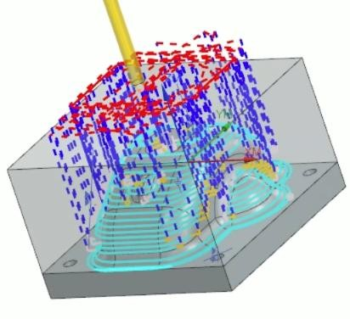
Figure 6: Cavity mill finishing using the ¼” ball flat mill.
The Cavity Mill Finish resulted in a poor finish with a large scallop height.

Complex Surface Milling Operation: Area Mill
This operation was conducted using the ¼” ball end mill to create a good quality surface finish with a minimum scallop height of 0.002”.
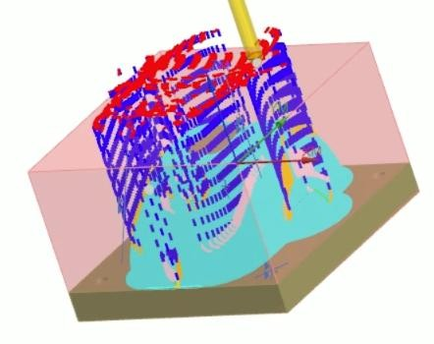
Figure 7: Area Mill using the ¼” ball end mill.
The non-steep cutting pattern was set to follow pat with a scallop stepover of 0.001”.

Planar Milling Operation: Pocketing
This operation involved making a 0.2” slot in the middle of the mouse. It was done using the 1/8” flat end mill.
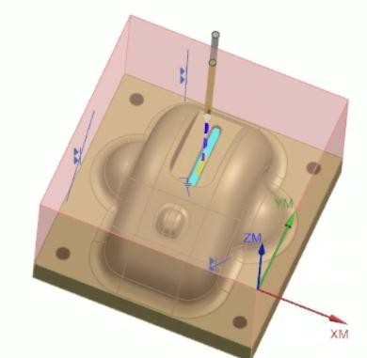
Figure 6: Pocketing operation with 1/8” flat end mill.

Hole Making Operation
A center drill with a tip diameter of 0.1” was used to spot drill on the corner holes and then a ¼” standard drill was used to make holes on the center drill spots. Center drill was important to do so that the standard drill does not wabble around.
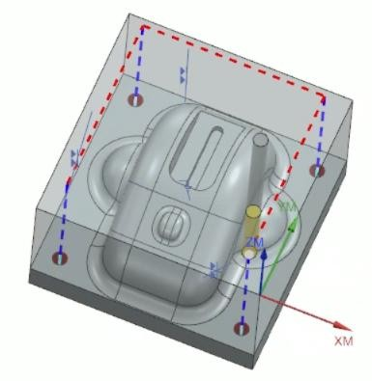
Figure 7: Hole making using ¼” standard drill.

CNC Machining Process

Machine Setup
The material was initially cut on the horizontal band saw from 4” x 4” x 24” ordered stock.
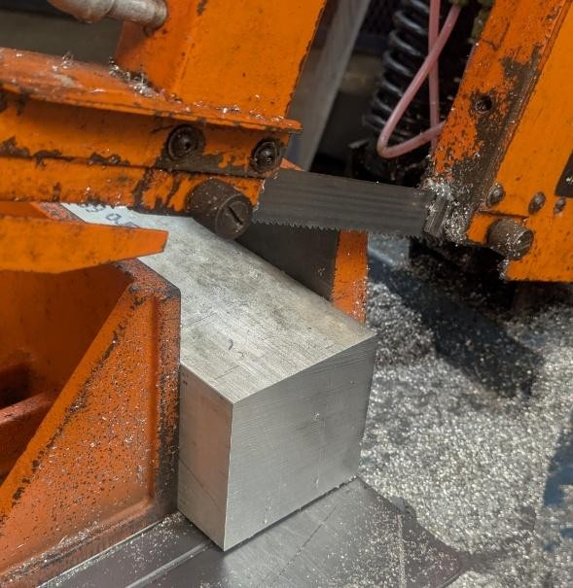
Figure 8: Cutting the blank in the horizontal band saw.
The cutout blank was then loaded on the manual mill and faced off using ¾” face cutter. Th ready to manufacture was then loaded on the CNC VF-2 Haas Milling Machine.
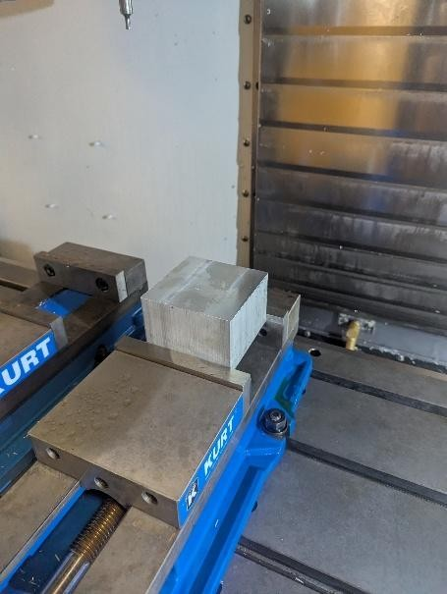
Figure 9: Blank clapped on vice with parallels in the CNC Machine.
The X and Y axes were zeroed using an edge finder with 0.2” diameter so the 0.1” radius was accounted for in the part zero offset.
Each tool was loaded into the machine according to the tool number set in the CAM program and zeroed using the 2” gauge block.
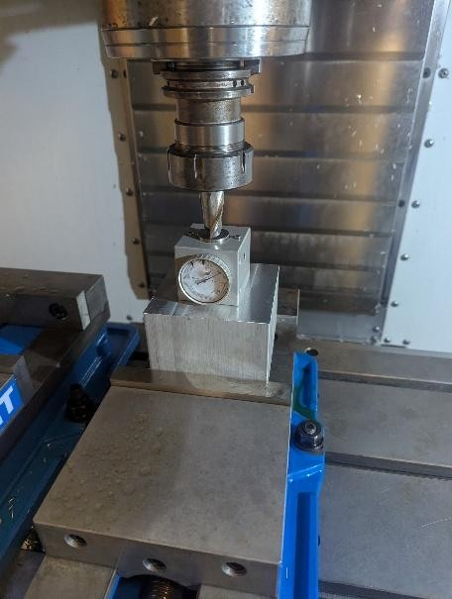
Figure 10: Tool Z axis Zero Process.

Program Execution
The operations started out well with no issues. A concern was about having enough tool stick out to avoid the holder hitting the part during machining. The minimum stick out required was 1.5” and that was accounted for when preparing the tools into the tool holders.
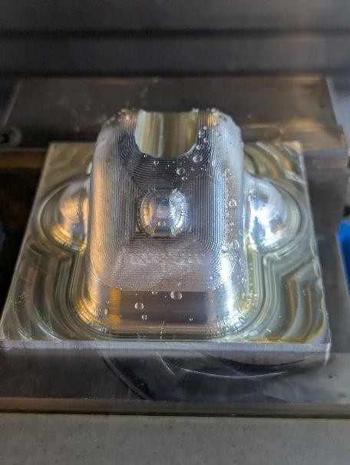
Figure 11: Part after area mill operation.

Problems Encountered During Machining
There were no issues during machining. The only concern was how close the tool holder was close to the part. There was only about 0.050” clearance. Making the part smaller or using tools that are longer would mitigate this concern.

Results and Evaluation

Finished Part
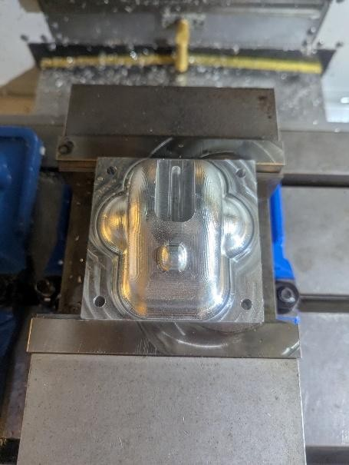
Figure 12: Part finished still on the machine.
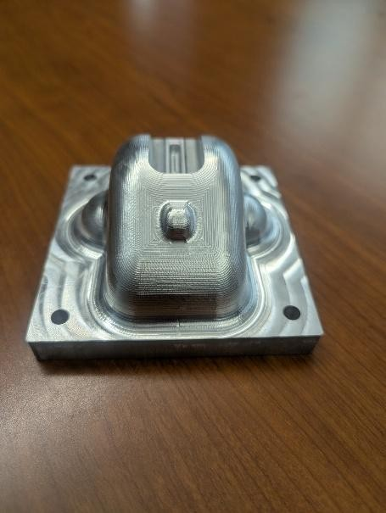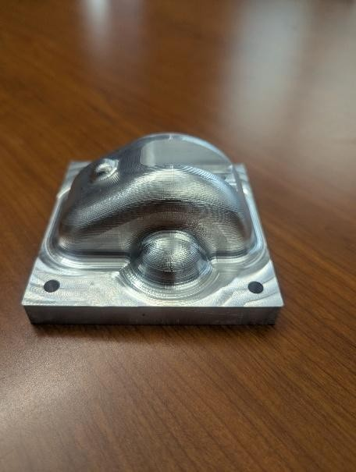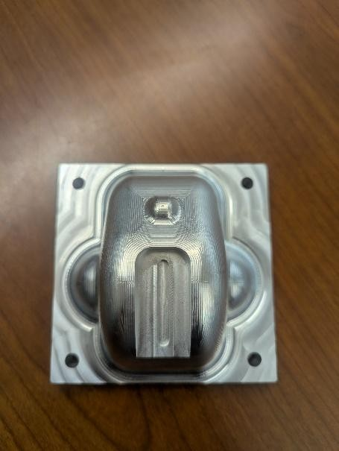
Figure 13: Part finished and cleaned.

Surface Finish Evaluation
The surface finish was good quality as expected with ¼” ball end mill and area mill scallop height of 0.001”. A much better surface quality can be achieved with a smaller diameter tool but the tradeoff would be more machining time.

Conclusion
Overall, the part came out well from the CNC machine. Furthermore, all required operations were done successfully on the part. The total setup and machining time was about 5 hours. An improvement may be using a smaller tool diameter for the area mill to get a smoother part but that would also increase machining time.

